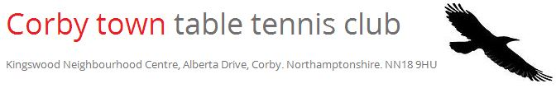
Coach Profile: Henry Arthur
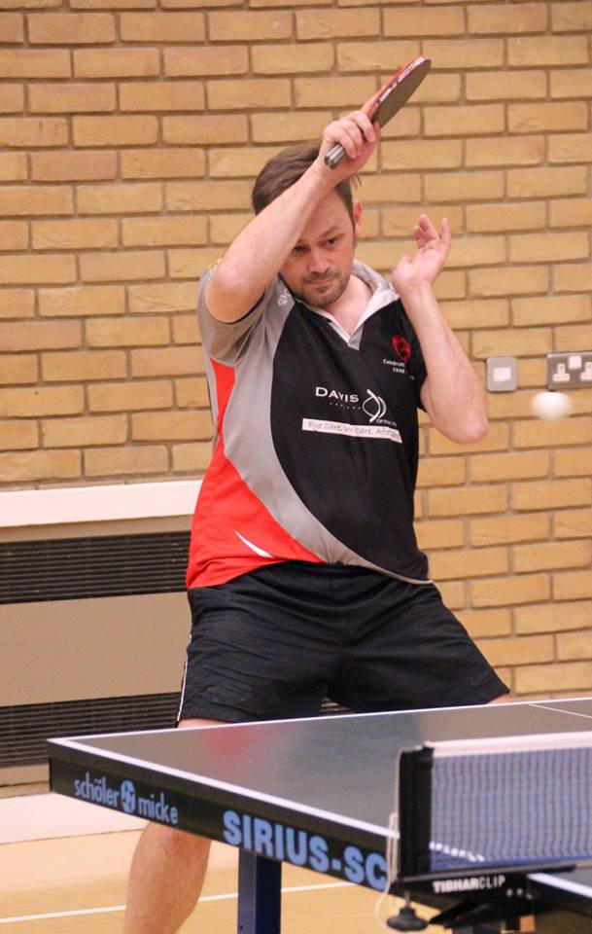

About me:
Born and bred in Corby, I have been into sport from an early age playing mainly football, cricket and table tennis. Have supported Everton FC since our glory days in the 1980s and long for those days to return!

Experience and qualifications:

Played for over 30 years. Competed in British League as well as local Kettering League and represent Northants in the County Championships. Claim to fame: Hold the record for most wins in one season in the Kettering league (set when I was 17 years old)! Best achievement-winning the Northants County Over 40 doubles title with Chris Haynes (we were also runner-up in the Men's doubles that year too).

I am a UKCC Level 3 Head Coach qualification. I have been coaching in a voluntary role since 2011 and professionally since 2015. I coach in several Primary and Secondary Schools across the County as well as coaching the Northants County Junior Squad. I am also a qualified multi-sports coach

My Favourites:
Film: Anything by Quentin Tarantino but couldn't pick just one.
Colour: Blue (Come on Everton)
Holiday Destination: What is a holiday?
Group / Singer: Oasis / Eminem
Drink: Tea
Food: I love pasta but it has to be steak for me!

